create table account

   (account_number      varchar(15) not null unique,

    branch_name         varchar(15) not null,

    balance             number            not null,

    primary key(account_number));

create table branch

   (branch_name   varchar(15) not null unique,

    branch_city   varchar(15) not null,

    assets        number            not null,

    primary key(branch_name));

create table customer

   (customer_name       varchar(15) not null unique,

    customer_street     varchar(12) not null,

    customer_city       varchar(15) not null,

    primary key(customer_name));

create table loan

   (loan_number   varchar(15) not null unique,

    branch_name         varchar(15) not null,

    amount        number            not null,

    primary key(loan_number));

create table depositor

   (customer_name       varchar(15) not null,

    account_number      varchar(15) not null,

    primary key(customer_name, account_number),

    foreign key(account_number) references account(account_number),

    foreign key(customer_name) references customer(customer_name));

create table borrower

   (customer_name       varchar(15) not null,

    loan_number   varchar(15) not null,

    primary key(customer_name, loan_number),

    foreign key(customer_name) references customer(customer_name),

    foreign key(loan_number) references loan(loan_number));

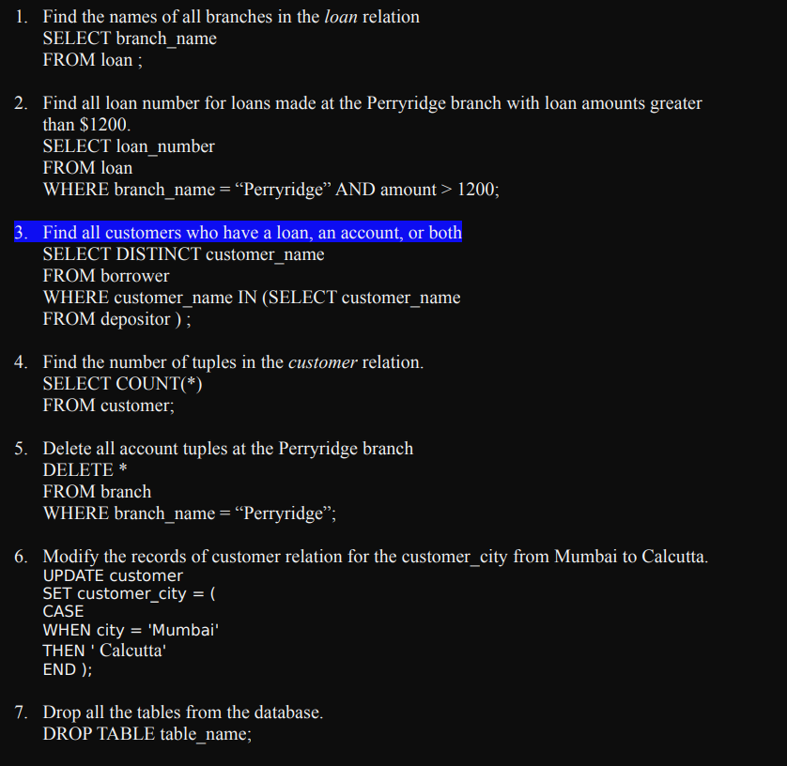

8. Write a query in sql to create a table employee and department. Employee(empno,ename,deptno,job,hiredate)

Department(deptno,dname,loc)

1. Include the following constraints on column of emp table.

a) to make the empno as primary key of the employee table and deptno as a primary key of department table

2) Perform the following complex queries

a) List dept no., Dept name for all the departments in which there are no employees in the department.

SELECT * FROM departments

WHERE department_id

NOT IN (select department_id FROM employees);

b) Count of number of employees in department wise

9. Write a query in sql to create a table employee and department. Employee(empno,ename,deptno,job,hiredate)

Department(deptno,dname,loc)

1. Include the following constraints on column of emp table.

a) to make the empno as primary key of the employee table and deptno as a primary key of department table

b) Select all records where ename starts with ‘S’ and its length is 6 char.

SELECT *

FROM employees

WHERE length(emp_name)=6

AND emp_name LIKE 'R%';\

c) Select all records where ename may be any no of character but it should end with ‘R’.

SELECT *

FROM employees

WHERE

emp_name LIKE '%R';\

d) Create a new user “abc” and give all privileges to it